**Quarkus ICCA Operator for Openshift for Nginx instance**

**(without dashboard ui)**

1. Login to <https://developer.ibm.com/openlabs/openshift>

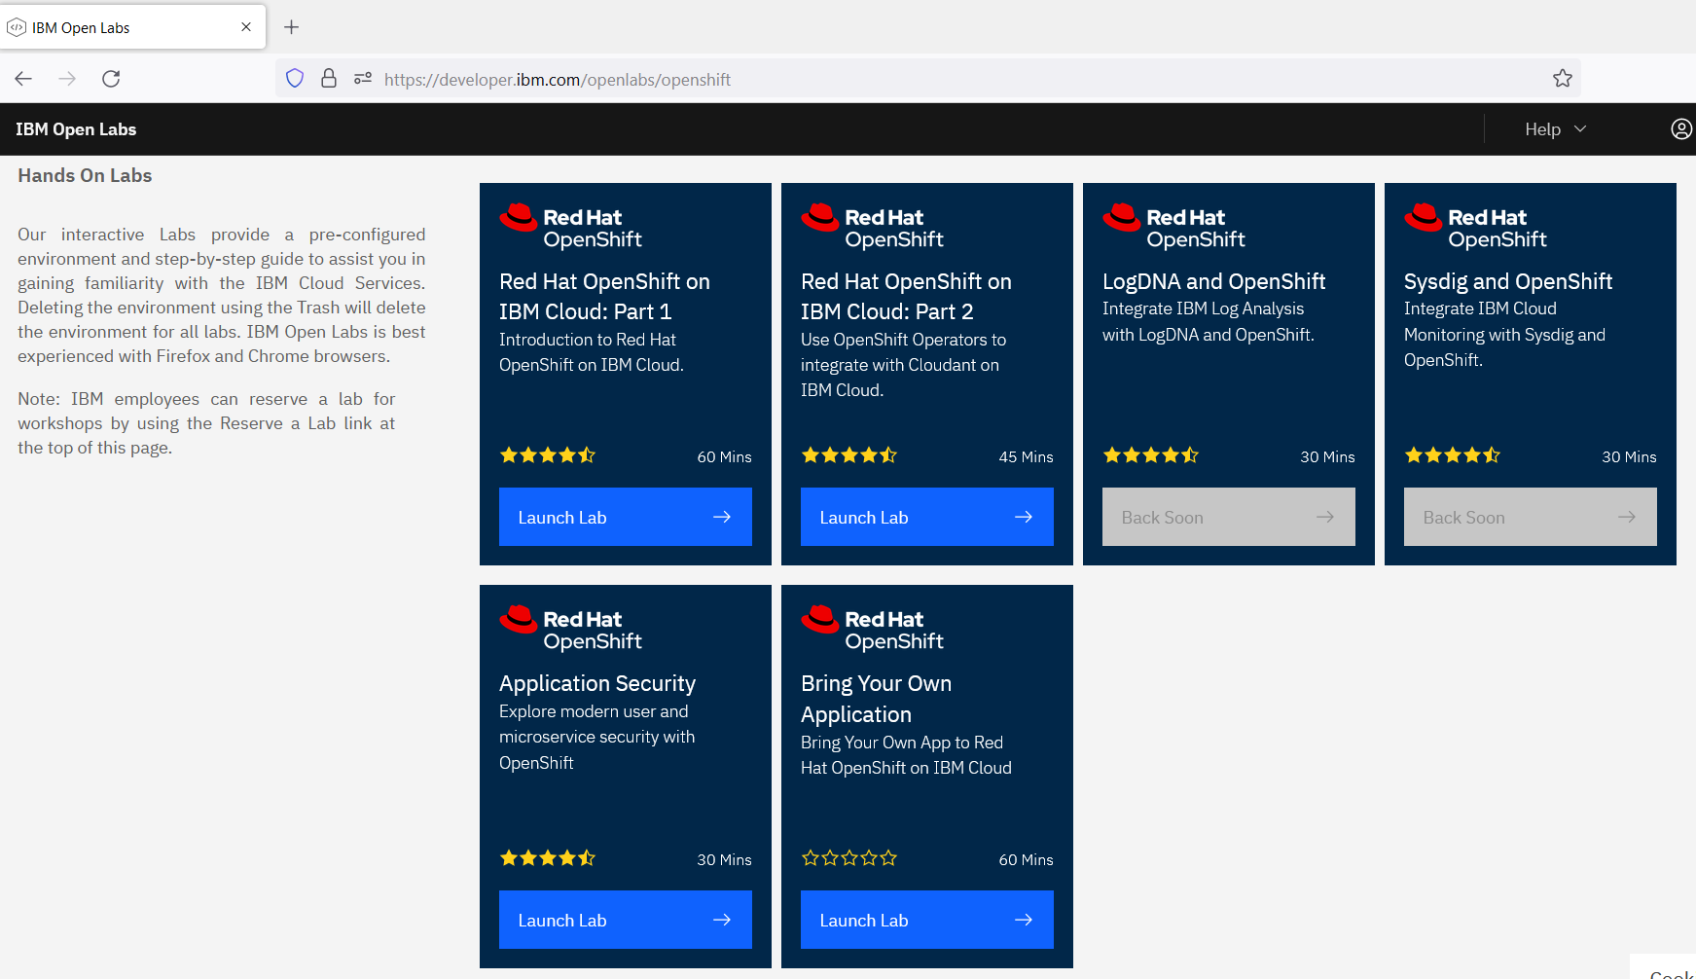

1. Launch a Lab

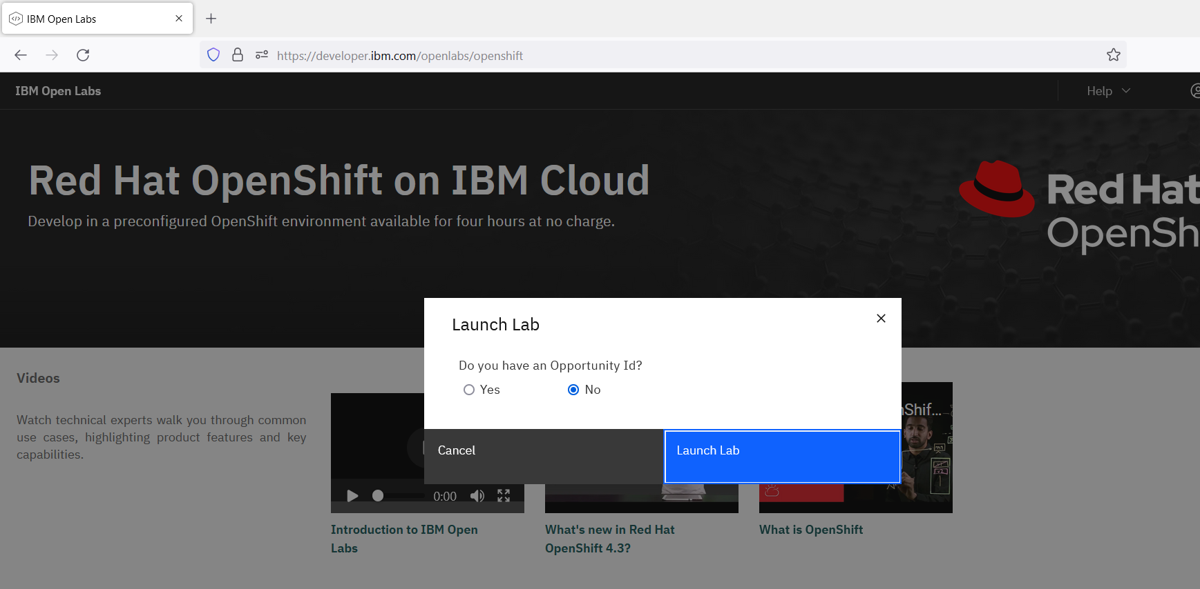

1. Click “Key” icon in following screen, located at top right corner

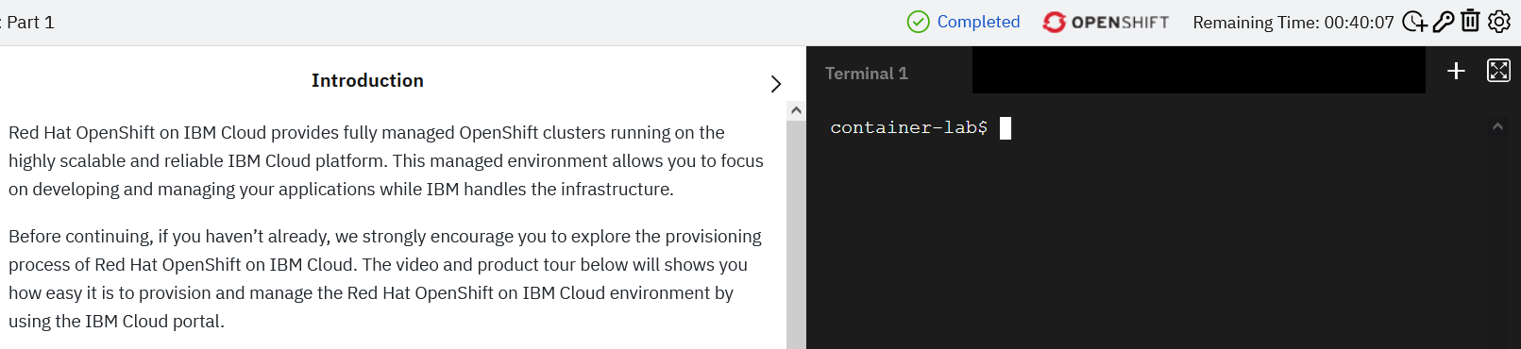

1. Copy oc login command from Pop Up screen

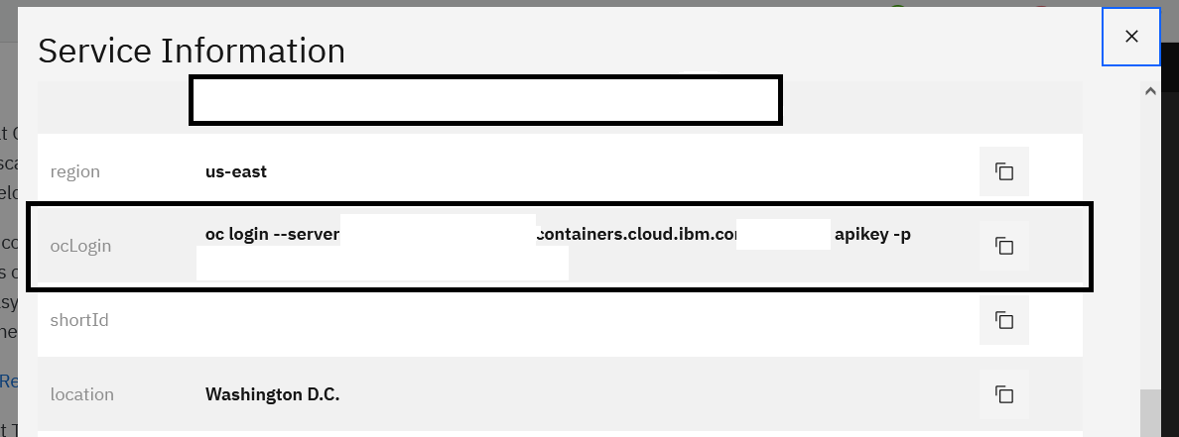

1. Run the login command from given terminal
2. Run

$ oc project default

1. Run

$ curl -O <https://raw.githubusercontent.com/rhm-samples/icca-operator-scripts/main/quarkus-op-with-crd.yml>

1. Run

$ oc apply -f quarkus-op-with-crd.yml

1. Run

$ curl -O <https://raw.githubusercontent.com/rhm-samples/icca-operator-scripts/main/nginx-instance.yml>

1. Run

$ oc apply -f nginx-instance.yml

**Verify Installation**

Wait for a minute before testing until deployments gets ready

1. Run

$ oc get svc --namespace quarkus-nginx-test -w nginx

**Success Criteria** : if service with “*nginx”* name is available. This confirms nginx installation in   
 *“quarkus-nginx-test”* namespace